

**Year 12 Chemistry**

**Organic Chemistry Test**

**Time allowed: 45 minutes**

**Name:___________________________________**

**Marks: ___________ / 45**

**Teacher: CEM NMO DGM JPT**

**Section 1: Multiple Choice Questions**

1. Which one of the following substances would you expect to have the highest boiling point?
2. CH3CH2 CH2CH2OH
3. C(CH3)4
4. CH3CH2CH2 CH2CH3
5. CH3COCH2CH3
6. Which functional groups are present in the following compound?

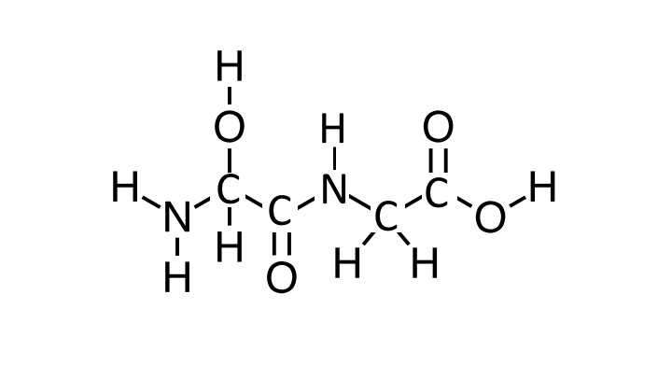

1. A carboxylic acid, two amines, an alcohol and a ketone
2. A carboxylic acid, an amine, an amide, and an alcohol
3. Two ketones, two amines, and two alcohols
4. A carboxylic acid, an amide and an alcohol
5. Which of the following bonds/interactions are responsible for the secondary structures of proteins?
6. The intermolecular forces between side chains of amino acids, including ion-dipole, dispersion forces, dipole-dipole attractions and hydrogen bonds.
7. The non-covalent interactions between the different polypeptide subunits that make up a multi-unit protein complex
8. The hydrogen bonds between the amide C=O and N-H on the peptide backbone.
9. The C-N peptide bonds between adjacent amino acids in a polypeptide chain.
10. Which of the following pairs of compounds could be most readily distinguished by the addition of acidified potassium permanganate:
11. Propanone and propanoic acid
12. Propanal and propan-1-ol
13. Propan-2-ol and propan-1-ol
14. Propanone and propanal
15. To synthesize methyl propanoate, one would react which of the following in acidic conditions:
16. Propan-1-ol and methanoic acid
17. Methanoic acid and propane
18. Methanol and propanoic acid
19. Methane and propan-2-ol
20. Below is a section of a polymer.

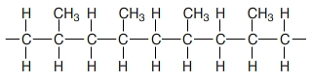

Which of the following are the monomer(s) from which the polymer is formed?

1. Methane and ethene
2. Propene
3. Propane
4. Propene and ethane
5. The following ester is hydrolysed in the presence of NaOH.

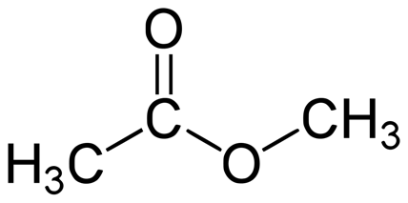

Which of the following correctly lists the two products of this hydrolysis reaction?

1. Methanol and sodium ethanoate
2. Methanol and ethanoic acid
3. Ethanol and methanoic acid
4. Ethanol and sodium methanoate
5. Which of the following compounds have the same empirical formula?

|  |  |
| --- | --- |
| 1. Ethanoic acid | 1. Ethanol |
| 1. Methyl methanoate | 1. Ethyl ethanoate |
| 1. Ethanal | 1. Propanone |

1. I, II and V
2. I and III
3. V and VI
4. None of the above
5. Which of the following statements is false?
6. Amino acids polymerise to form long polypeptide chains joined by amide linkages
7. Ethene undergoes an addition reaction with bromine to form 1,1 dibromoethane
8. Polyamides and polyesters are both examples of condensation polymers
9. Cyclobutane and cis-but-2-ene have the same empirical formula
10. Which of the following compounds would you expect to be the least soluble in water?
11. Propane
12. Hexane
13. Propanol
14. Hexanal

**Section 2: Short Answer Section:**

**Question 1 6 marks**

Give the name and structural formula of the **main organic product(s)** for the following reactions:

|  |  |  |  |
| --- | --- | --- | --- |
|  | Reaction | Structural Formula of the main organic product(s) | Name of the main organic product(s) |
| a) | Excess acidified potassium dichromate is added to propan-2-ol |  |  |
| b) | Bromine water is added to *cis*-but-2-ene |  |  |
| c) | Chloroethene forms an addition polymer. Draw a section of the polymer containing 3 monomer units  **NB. No name is required** |  | |

(6 marks)

**Question 2 9 marks**

Give a chemical test that could be used to distinguish between the following two chemicals. Describe any observations.

1. Propanoic acid and Propanone

Chemical test: _____________________________________________________________________

Observations:

|  |  |
| --- | --- |
| Propanoic acid | Propanone |

(3 marks)

1. Pentan-1-ol and 2-methyl butan-2-ol

Chemical test: _____________________________________________________________________

Observations:

|  |  |
| --- | --- |
| pentan-1-ol | 2-methyl butan-2-ol |

(3 marks)

1. Pentan-1-ol and 2-methyl butan-2-ol can also be separated by physical means, using differences in their boiling points. Predict which compound will have the higher boiling point and explain your response.

____________________________________________________________________________________________________________________________________________________________________________________________________________________________________________________________________________________________________________________________________________________________________________________________________________________________________________________________________________________________________________

(3 marks)

**Question 3 3 marks**

Below is a section of a polymer, showing 2 repeating units.

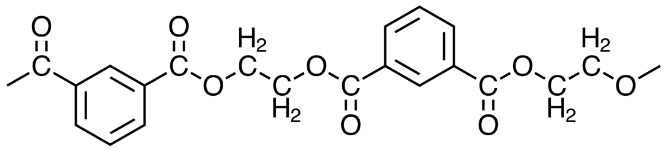

1. To which class of polymer does this compound belong? (1 mark)

_________________________________________________________________________________

1. Draw the two monomer units that were used to form this polymer.

|  |  |
| --- | --- |
| Monomer 1 | Monomer 2 |

(2 marks)

**Question 4 4 marks**

Aspartame is an artificial sweetener also known as Equal or Splenda. It was discovered by accident in 1965 by a scientist wanting to synthesise a tetrapeptide for another purpose, when he licked his finger to pick up a piece of paper. It is a methyl ester of the dipeptide Asp – Phe.

1. Draw the structure of the dipeptide Asp-Phe as it would exist under strongly acidic conditions.

|  |
| --- |
|  |

(2 marks)

1. Aspartame is formed when methanol is reacted with the dipeptide Asp - Phe under acidic conditions. It is a monoester, not a diester. Using this information, draw the two possible structures for aspartame in the space below.

|  |
| --- |
| Structure 1 |
| Structure 2 |

(2 marks)

**Question 5 3 marks**

The tertiary structure of a protein can involve many different types of interactions. If the four amino acids shown below are found in close proximity on the same polypeptide chain, state the dominant type of interaction that would exist at pH 7 between the side chains of the amino acids listed.

|  |  |
| --- | --- |
| Phenylalanine  https://upload.wikimedia.org/wikipedia/commons/a/af/Phenylalanine.png | Serine  https://upload.wikimedia.org/wikipedia/commons/b/bb/Serine.png |
| Threonine  https://upload.wikimedia.org/wikipedia/commons/a/a9/Threonine.png | Cysteine  https://encrypted-tbn0.gstatic.com/images?q=tbn:ANd9GcS2B4ooF_9RsS6l7tigHpD25TRaWr-pWSqZqMgUkF0HHZWpVZDy5Q |

1. Serine and threonine

___________________________________________________________________________

1. Phenylalanine and Serine

___________________________________________________________________________

1. Cysteine and Serine

___________________________________________________________________________

(3 marks)

**Question 6 10 marks**

Fats are triglyceride molecules containing 3 ester groups. They can used as precursors to produce both soaps and biodiesel. Glycerol is produced as a by-product in both synthetic reactions.

1. Write balanced reactions in the space below to show how the tristearin molecule below (a fat) can be used to produce both a soap and biodiesel.

|  |
| --- |
| Soap  http://wps.prenhall.com/wps/media/objects/340/348272/Instructor_Resources/Chapter_25/Text_Images/FG25_01.JPG  **+ 🡪** |
| Biodiesel  http://wps.prenhall.com/wps/media/objects/340/348272/Instructor_Resources/Chapter_25/Text_Images/FG25_01.JPG  **+ 🡪** |

(6 marks)

1. Detergents and soaps share many structural similarities that enable them to act as cleaning agents. Sodium dodecyl sulfate (CH3(CH2)11OSO3-) is a commonly used detergent and its structure is shown below:

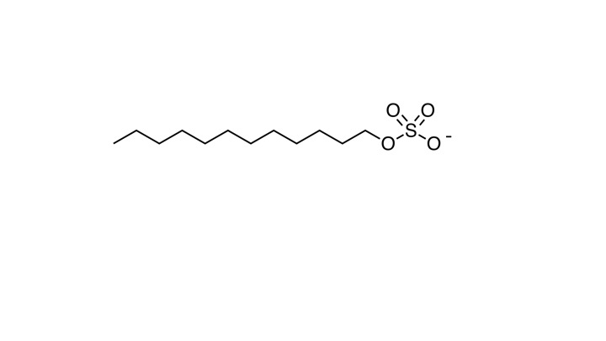

1. Discuss the similarities in the structures of soaps and detergents that enable them to remove oil and grease from surfaces

__________________________________________________________________________________________________________________________________________________________________________________________________________________________________________________________________________________________________________________________________________________________________________________________________________________________

(2 marks)

1. Soaps are less effective than detergents when used in hard water. Explain this observation

__________________________________________________________________________________________________________________________________________________________________________________________________________________________________________________________________________________________________________________________________________________________________________________________________________________________

(2 marks)